Lab 06

Q1.

views.py

from django.shortcuts import render

from .forms import ArithmeticForm

def calculate(request):

result = None

if request.method == 'POST':

form = ArithmeticForm(request.POST)

if form.is_valid():

num1 = form.cleaned_data['number1']

num2 = form.cleaned_data['number2']

operation = form.cleaned_data['operation']

if operation == 'add':

result = num1 + num2

elif operation == 'subtract':

result = num1 - num2

elif operation == 'multiply':

result = num1 * num2

elif operation == 'divide':

if num2 != 0:

result = num1 / num2

else:

result = 'Error: Division by zero'

else:

form = ArithmeticForm()

return render(request, 'calculator/index.html', {'form': form, 'result': result})

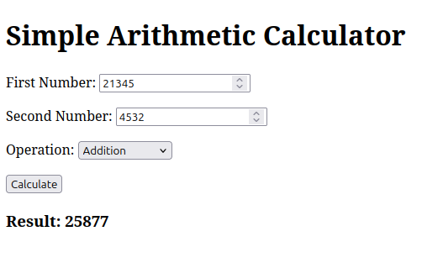

Q2.

views.py

from django.shortcuts import render

from .forms import MagazineCoverForm

from PIL import Image

from PIL import ImageDraw, ImageFont

import io

from django.core.files.storage import default_storage

import base64

def create_magazine_cover(request):

result_image = None # To hold the image data for displaying on the template

if request.method == 'POST':

form = MagazineCoverForm(request.POST, request.FILES)

if form.is_valid():

title = form.cleaned_data['title']

subtitle = form.cleaned_data['subtitle']

text_color = form.cleaned_data['text_color']

bg_color = form.cleaned_data['bg_color']

font_size = form.cleaned_data['font_size']

image_file = form.cleaned_data['image'] # The uploaded image

# Create the base image (for simplicity, a 600x800 px cover)

base_image = Image.new('RGB', (600, 800), color=bg_color)

# Draw text on the image (simple method for demonstration)

draw = ImageDraw.Draw(base_image)

try:

font = ImageFont.truetype("arial.ttf", font_size)

except IOError:

font = ImageFont.load_default()

title_position = (30, 50)

subtitle_position = (30, 150)

draw.text(title_position, title, fill=text_color, font=font)

draw.text(subtitle_position, subtitle, fill=text_color, font=font)

# Add the uploaded image

uploaded_image = Image.open(image_file)

uploaded_image = uploaded_image.resize((550, 400)) # Resize to fit cover

base_image.paste(uploaded_image, (25, 250))

# Save the final image to a BytesIO object for display

buffer = io.BytesIO()

base_image.save(buffer, format="PNG")

buffer.seek(0)

# Create a URL or base64 encoded string of the image

result_image = base64.b64encode(buffer.read()).decode('utf-8') # Convert image to base64 string

else:

form = MagazineCoverForm()

return render(request, 'magazine/magazine_cover.html', {

'form': form,

'result_image': result_image

})

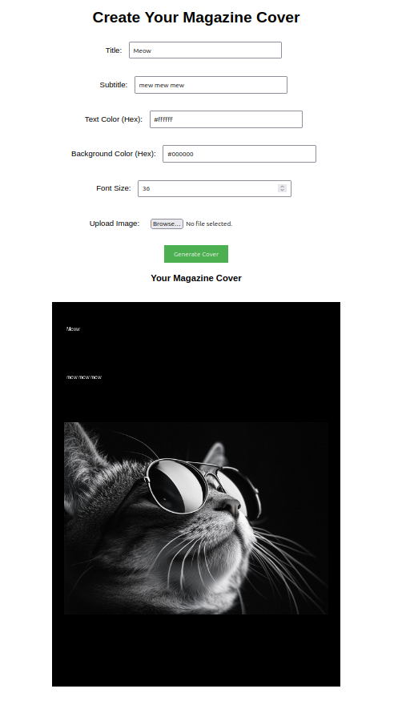

Q3.

home.html

<html>

<head>

<title>Book Information</title>

{% load static %}

</head>

<body>

<h1>Book Title</h1>

<img src="{% static 'book_cover.jpg' %}" alt="Book Cover" width="200">

<ul>

<li><a href="{% url 'metadata' %}">Metadata</a></li>

<li><a href="{% url 'reviews' %}">Reviews</a></li>

<li><a href="{% url 'publisher_info' %}">Publisher Info</a></li>

</ul>

</body>

</html>

metadata.html

<html>

<head>

<title>Book Information</title>

{% load static %}

</head>

<body>

<h1>Book Title</h1>

<img src="{% static 'book_cover.jpg' %}" alt="Book Cover" width="200">

<ul>

<li><a href="{% url 'metadata' %}">Metadata</a></li>

<li><a href="{% url 'reviews' %}">Reviews</a></li>

<li><a href="{% url 'publisher_info' %}">Publisher Info</a></li>

</ul>

</body>

</html>

reviews.html

<html>

<head>

<title>Reviews</title>

{% load static %}

</head>

<body>

<h1>Book Reviews</h1>

<p>"A great book!" - Reviewer 1</p>

<p>"Really engaging story!" - Reviewer 2</p>

<a href="{% url 'home' %}">Back to Home</a>

</body>

</html>

publisher_info.html

<html>

<head>

<title>Publisher Info</title>

{% load static %}

</head>

<body>

<h1>Publisher Information</h1>

<p>Publisher: XYZ Publishers</p>

<p>Location: New York, USA</p>

<a href="{% url 'home' %}">Back to Home</a>

</body>

</html>

